**Microsoft Azure**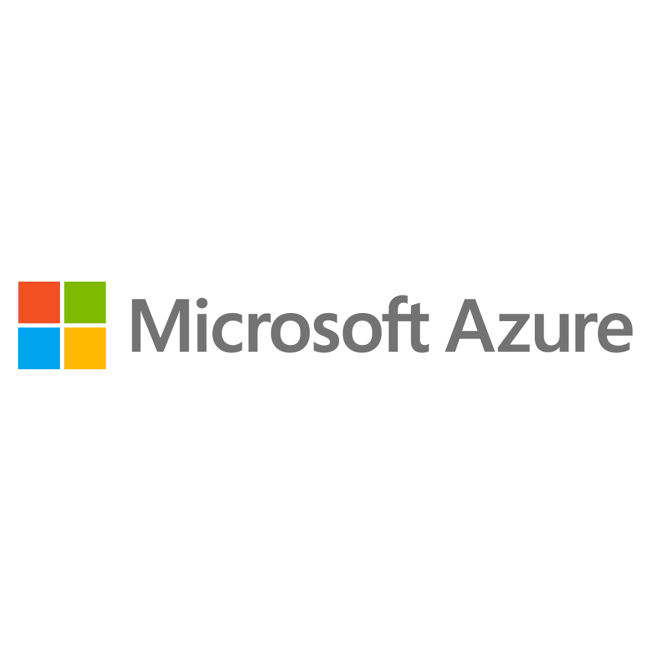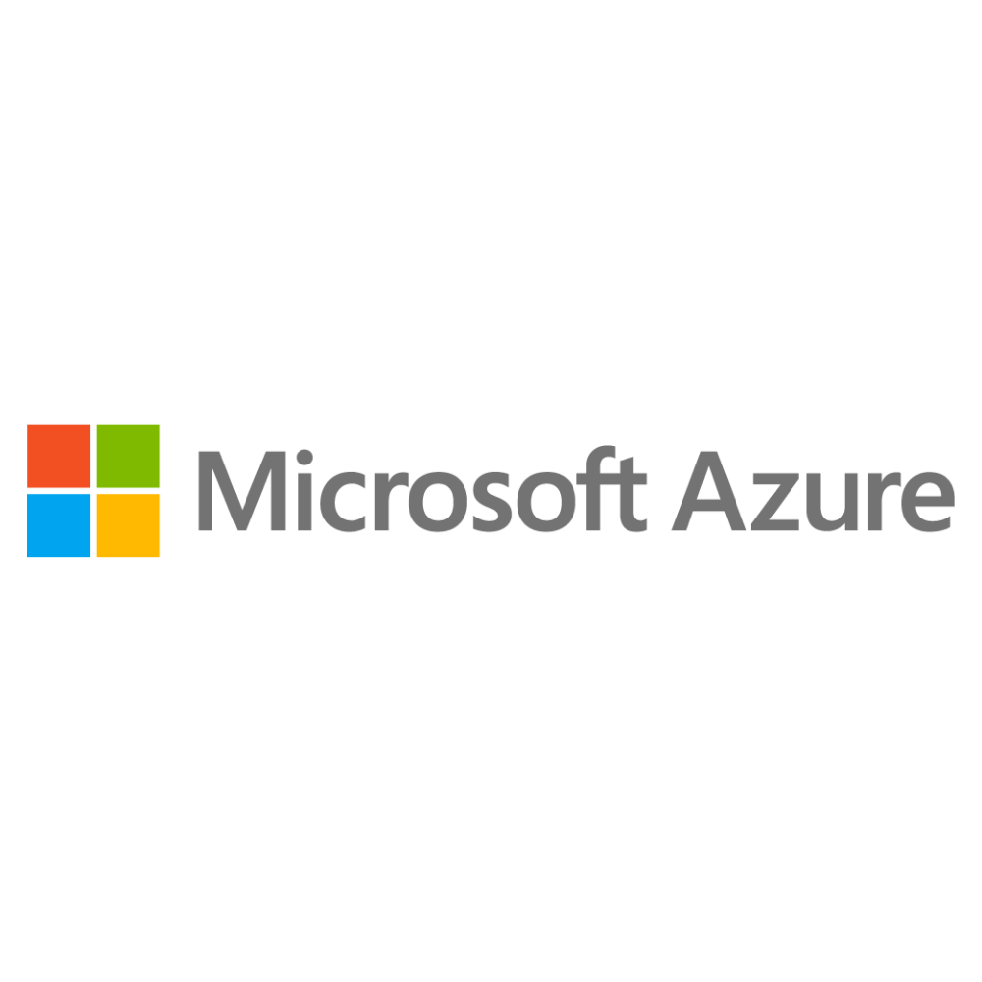

**[Nilavembu Herbs]**

**[Azure Case Study]**

**Manish Choudhary**

**Clouds Operation Engineer- Batch 1**

**Method of Procedure for Nilavembu Herbs case study with screenshot**

**Table of Content:**

1. Creating resource group (Southeast Asia and East US) 3
2. Southeast Asia Region setup 4
   1. Creating and configuring Virtual network 4
   2. Creating and configuring availability set 5
   3. Creating and configuring network security group 6
   4. Creating 3 virtual machine 7
   5. Creating and setting load balancer 13
   6. Installing IIS service in Southeast Asia VMs to make it webserver 17
   7. Enabling and configuring backup 18
   8. Creating alert rule 20
3. East US Region setup
   1. Creating virtual network in East US 24
   2. Creating virtual machine 24
   3. Establishing secure connection to SEA-EUS acquire sites through peering 26
   4. Servers are reachable with internal ip addresses 27
4. Storage Requirement 28
5. Creating files share 29
6. Creating storage account in SEA region with Geo-redundant storage to be

used in multiple azure data centre failure 30

1. Azure Resource Management 31
2. Adding roles to the existing users 32

A **resource group** is a container that holds related resources for an Azure solution. Generally, add resources that share the same lifecycle to the same resource group so you can easily deploy, update, and delete them as a group.

* **Creating resource group in SEA region.(SEA_region)**

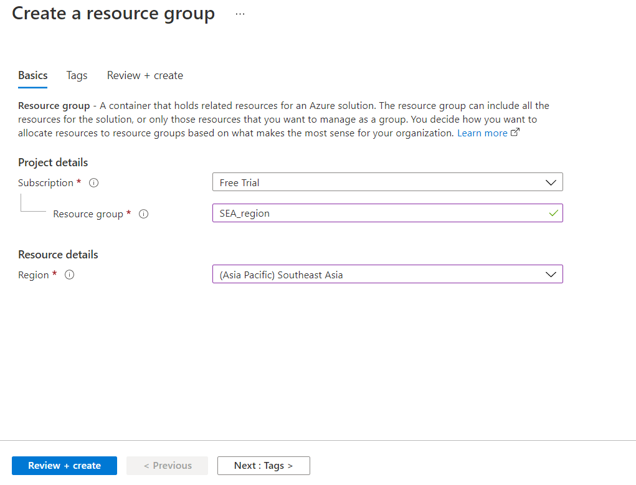

* **Creating a resource group in EUS region.(EastUS_region)**

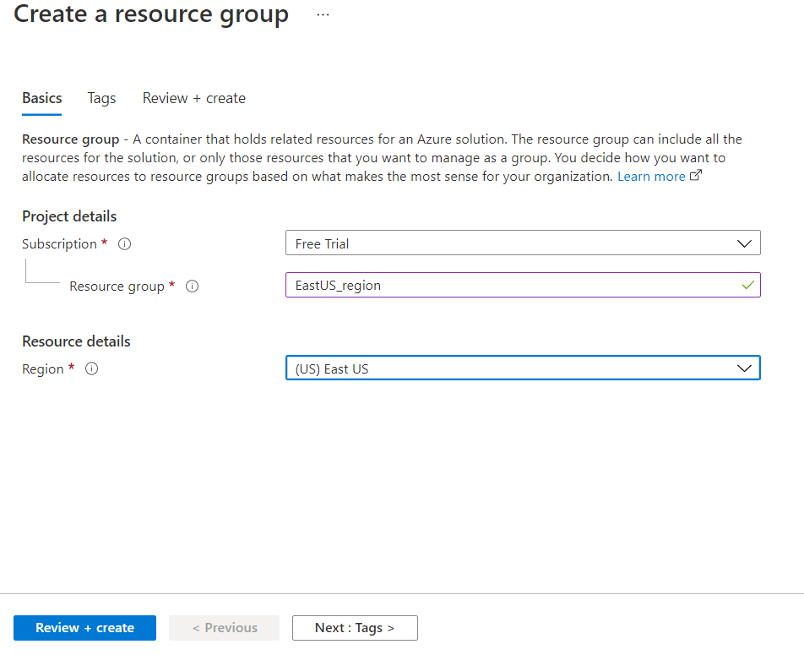

**(Working in South East Asia region SEA)**

* **Creating two subnets in virtual network for SEA region:**
  + **Azure Virtual Network (VNet) is the fundamental building block for your private network in Azure. It enables Azure resources to securely communicate with each other, the internet, and on-premises networks.**
  + **Instance name:** sea_nw
  + **Subnet name:** sea_webserver(10.0.13.0/24) and sea_jumpport(10.0.14.0/24)

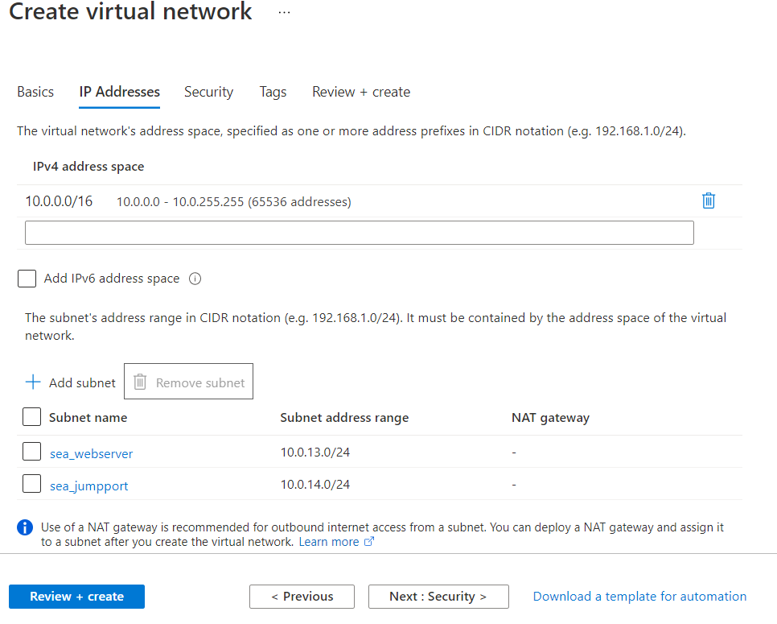

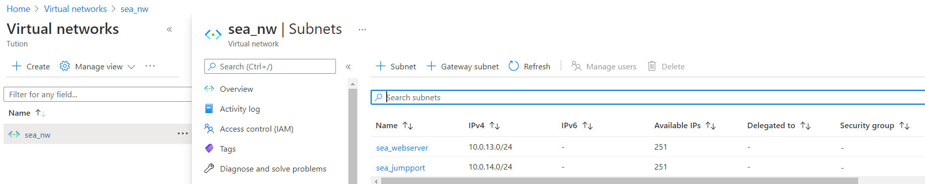

* **Creating Availability set. (wserver_asea)**
* An availability set is a logical grouping of VMs that allows Azure to understand how your application is built to provide for redundancy and availability. **With 2 fault domains so that we can achieve high availability of 99.95 %.**

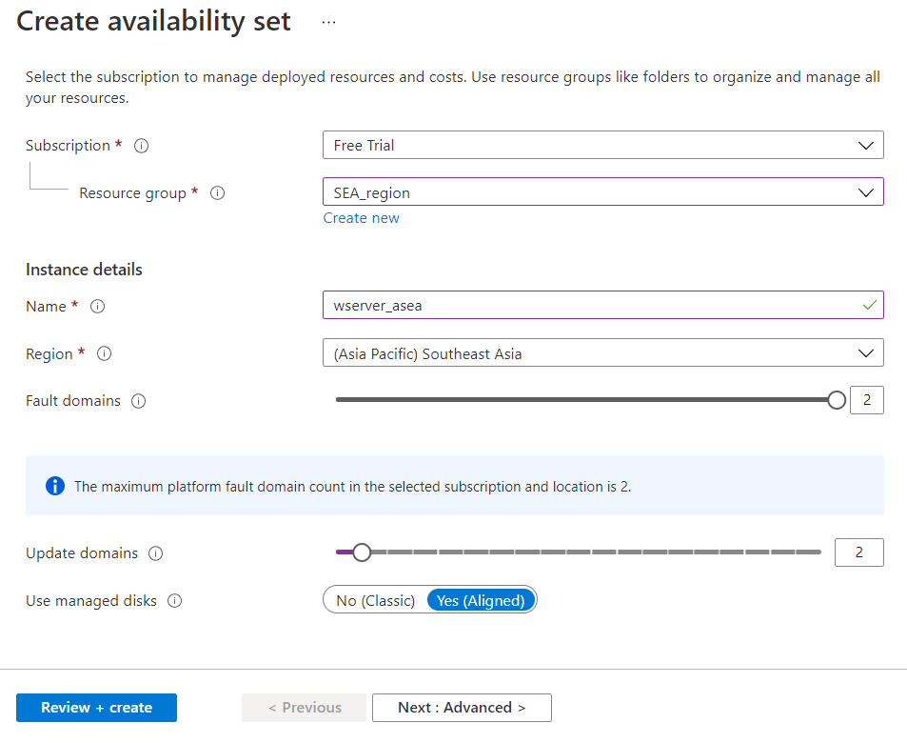

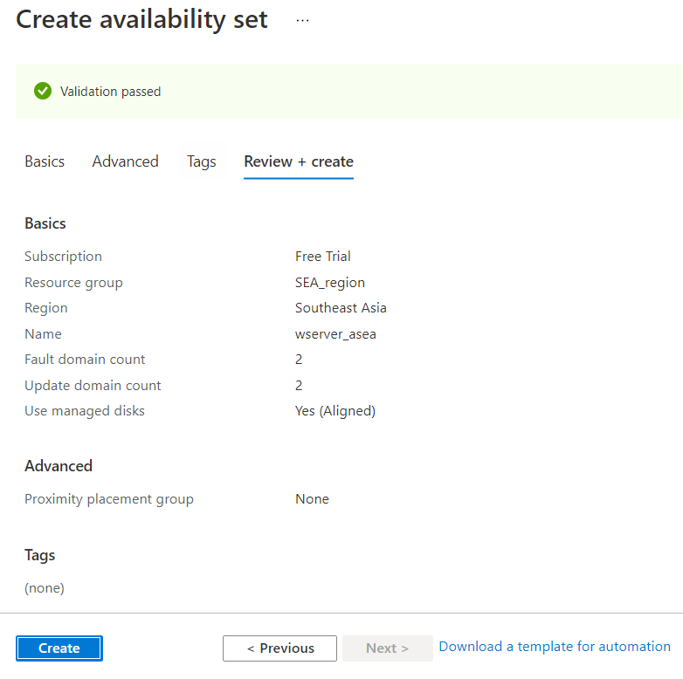

Azure **network security group** to filter network traffic to and from Azure resources in an Azure virtual network. A network security group contains security rules that allow or deny inbound network traffic to, or outbound network traffic from, several types of Azure resources. **For each rule, you can specify source and destination, port, and protocol.**

* **Creating NSG – nsg_sea**

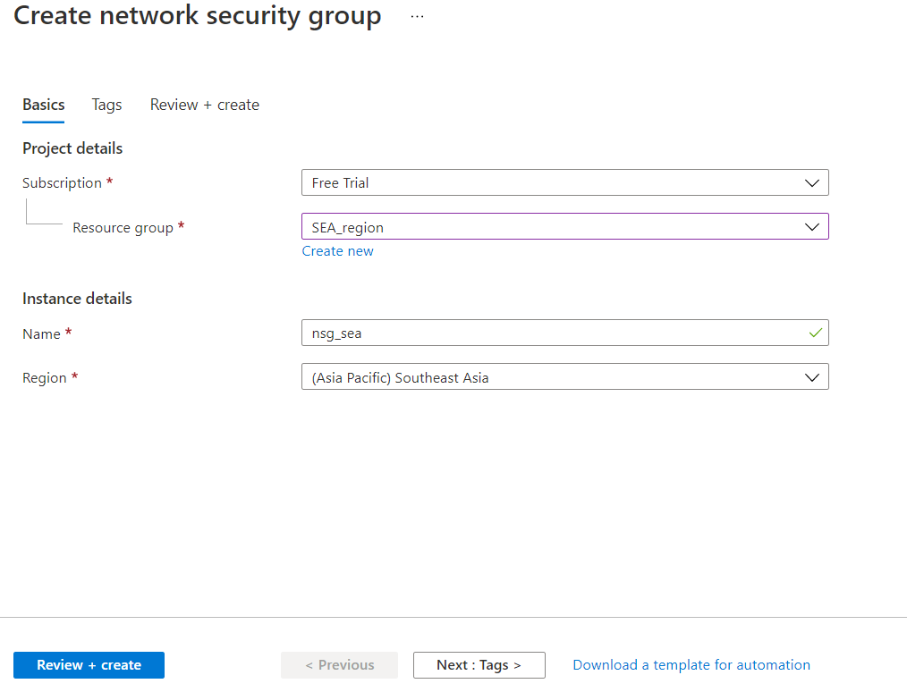

Azure Virtual Machines (VM) is **one of several types of on-demand, scalable computing resources that Azure offers**. ... An Azure VM gives you the flexibility of virtualization without having to buy and maintain the physical hardware that runs it. In this case study we are using Dv4 family machines which are best recommended for general purpose needs.

* **Creating Virtual Machine for SEA region.(sea-ws)**

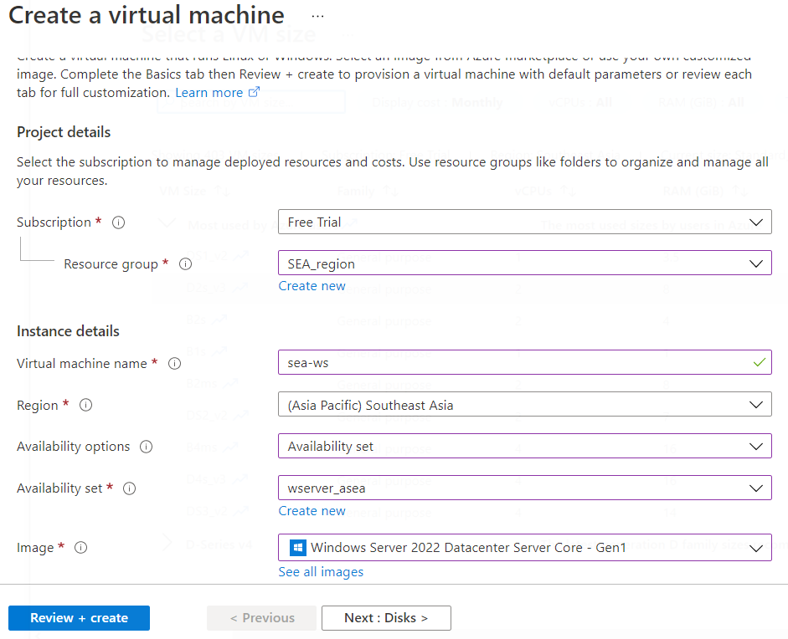

* **Setting OS disk type to Standard SSD.**

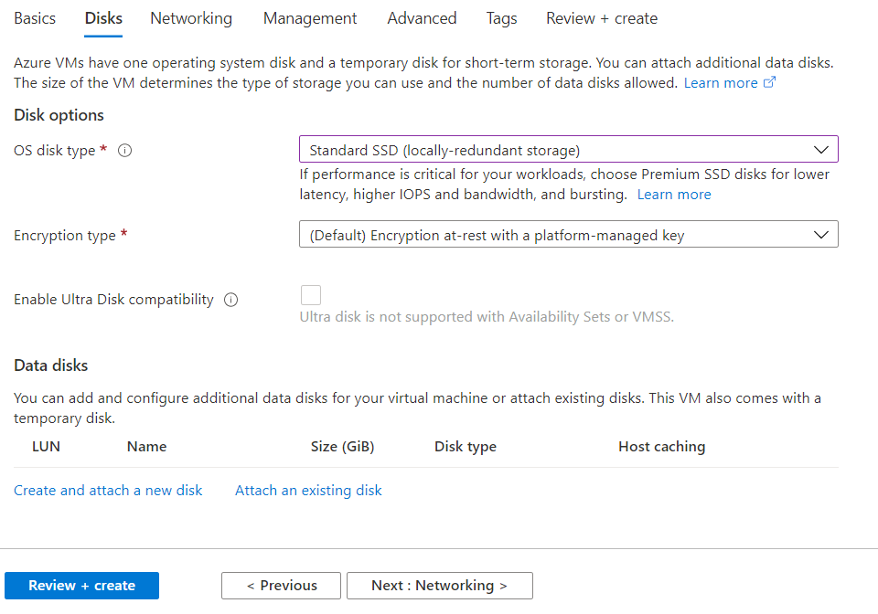

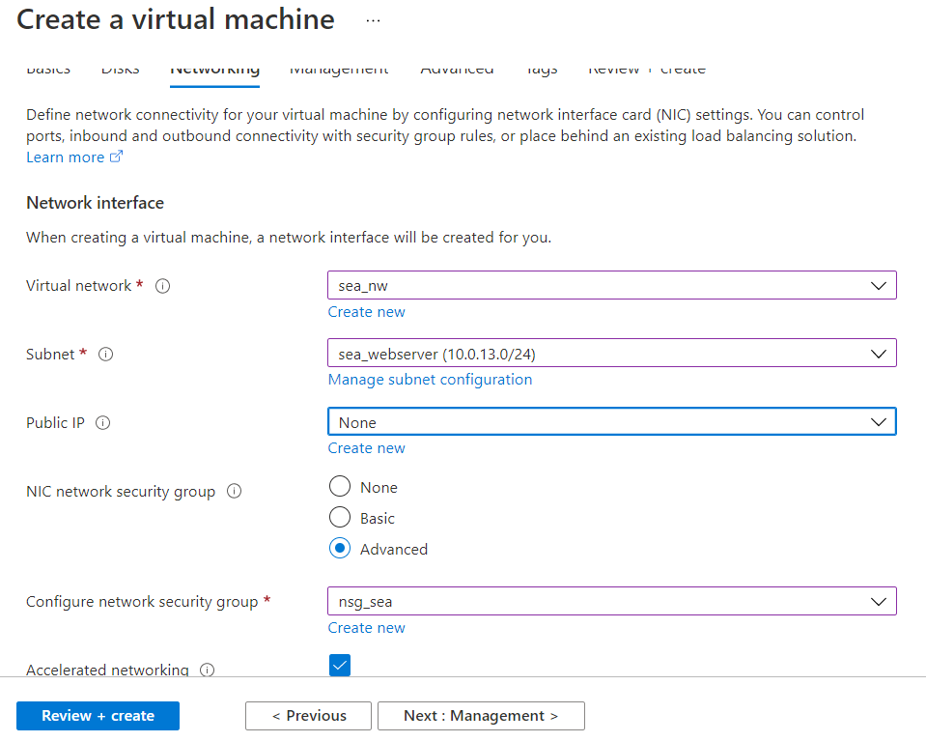

* **Creating Virtual Machine for SEA region. (sea-ws2)**

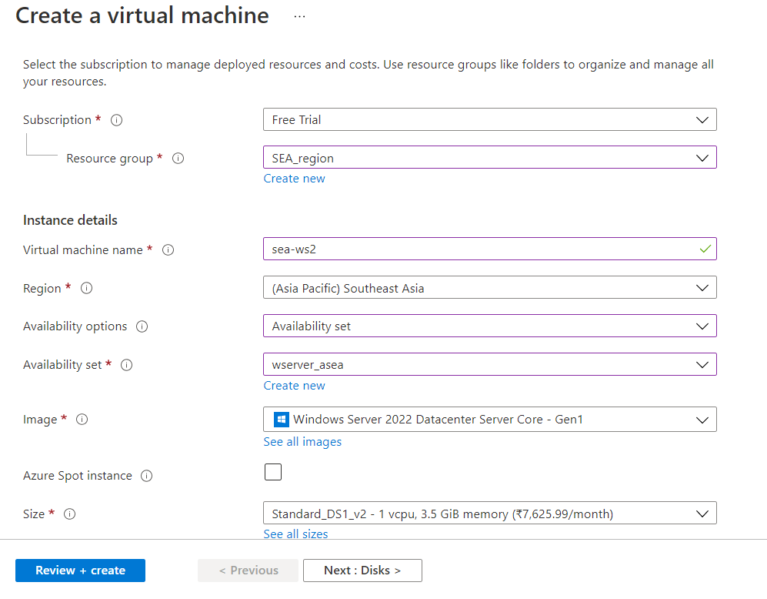

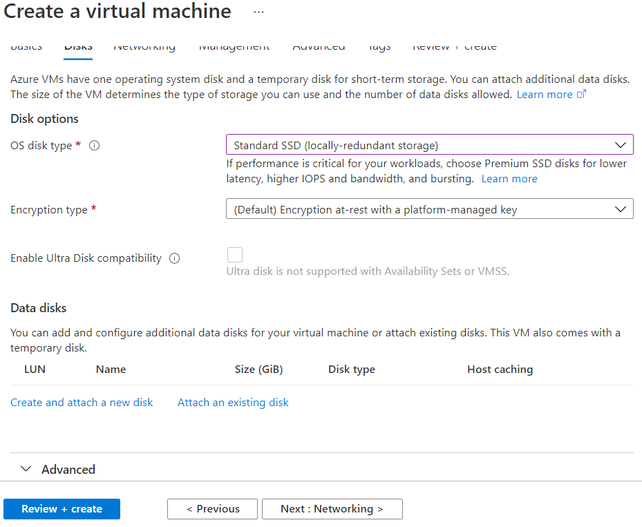

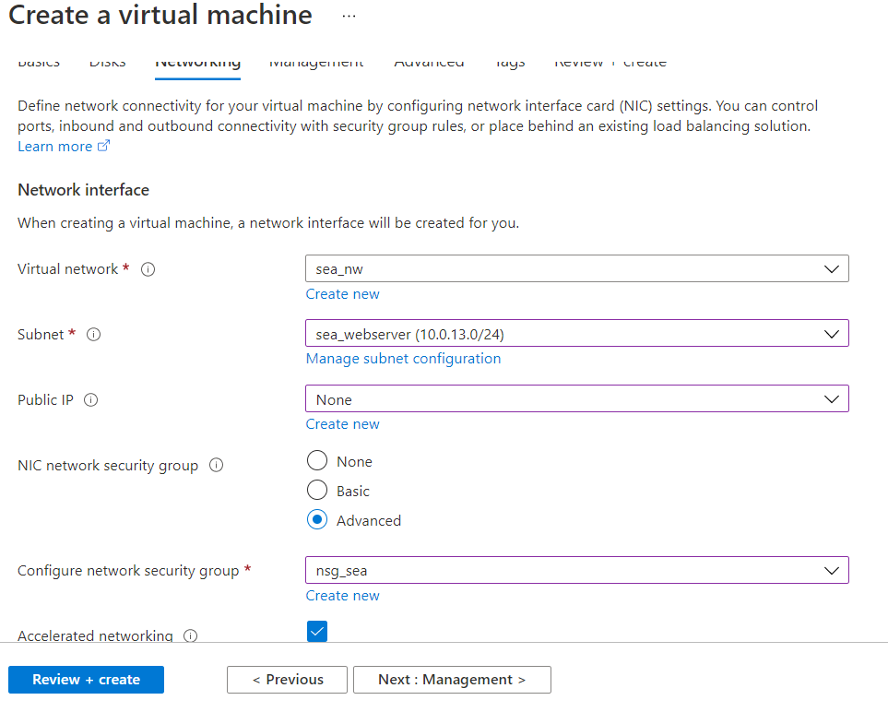

* **Creating a VM in SEA region. (sea-jumpport)**

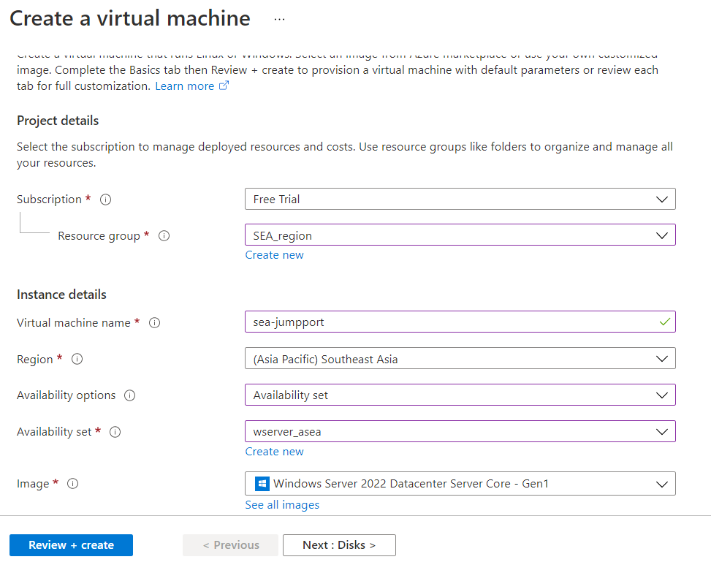

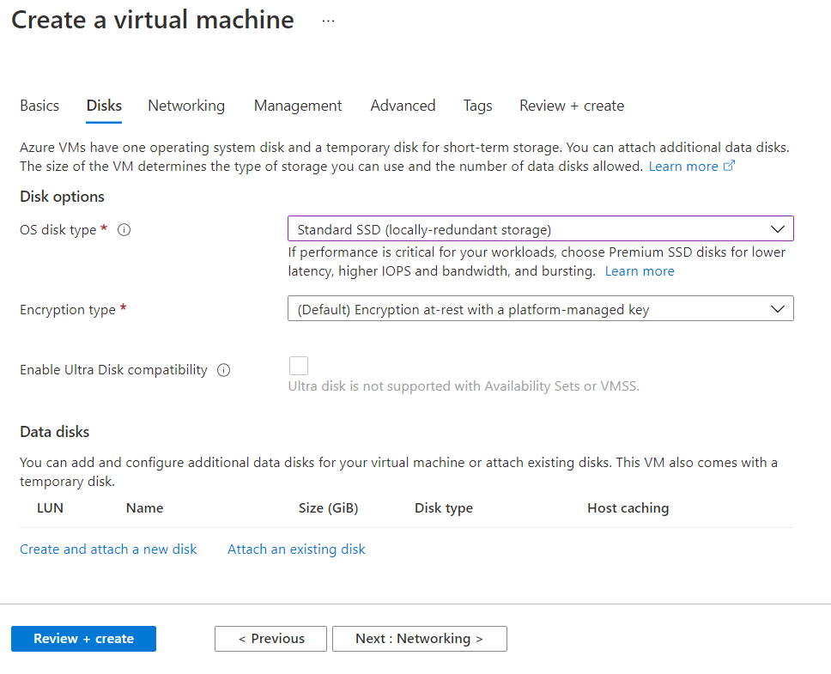

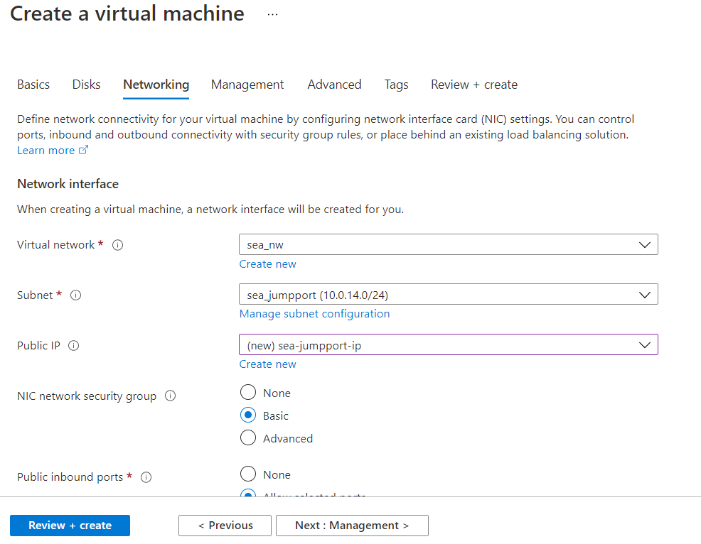

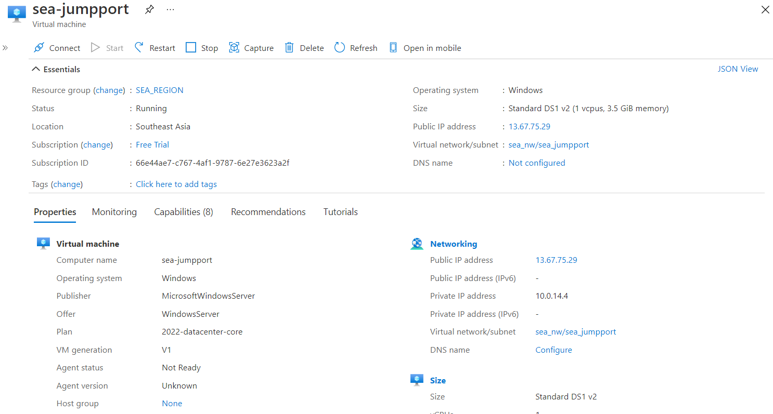

* **Creating load balancer.**

**For secuirity purpose as it will control the traffic and also gives client affinity.**

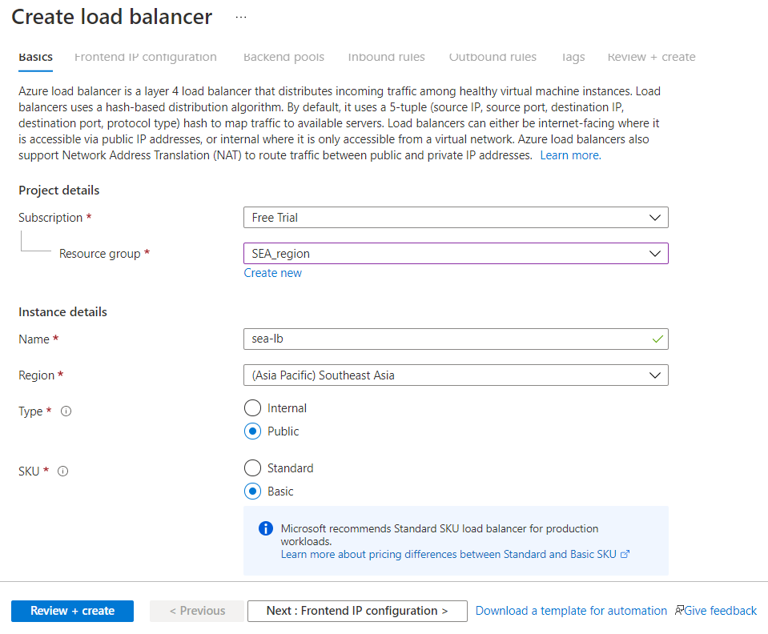

**We have used a basic load balancer as we have a few servers, so our purpose is achieved.**

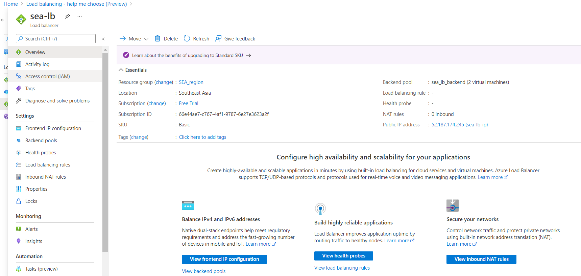

* **Adding backend pool in load balancer**

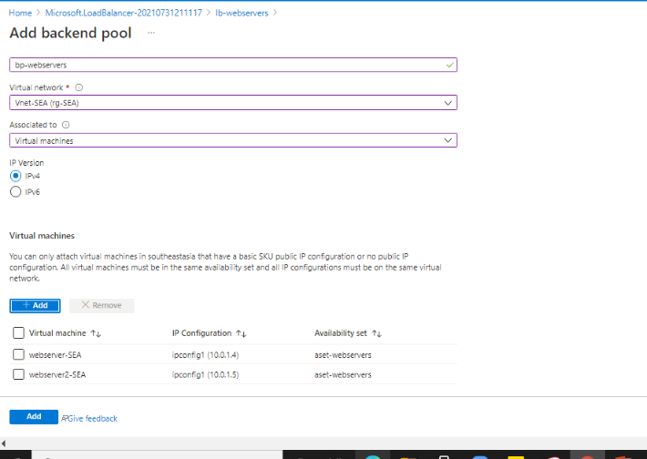

* **Adding load balancing rule**

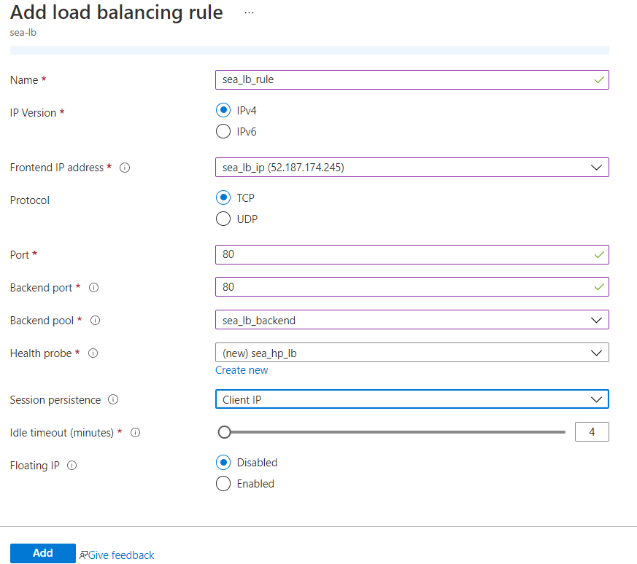

* **Adding inbound NAT rule.**

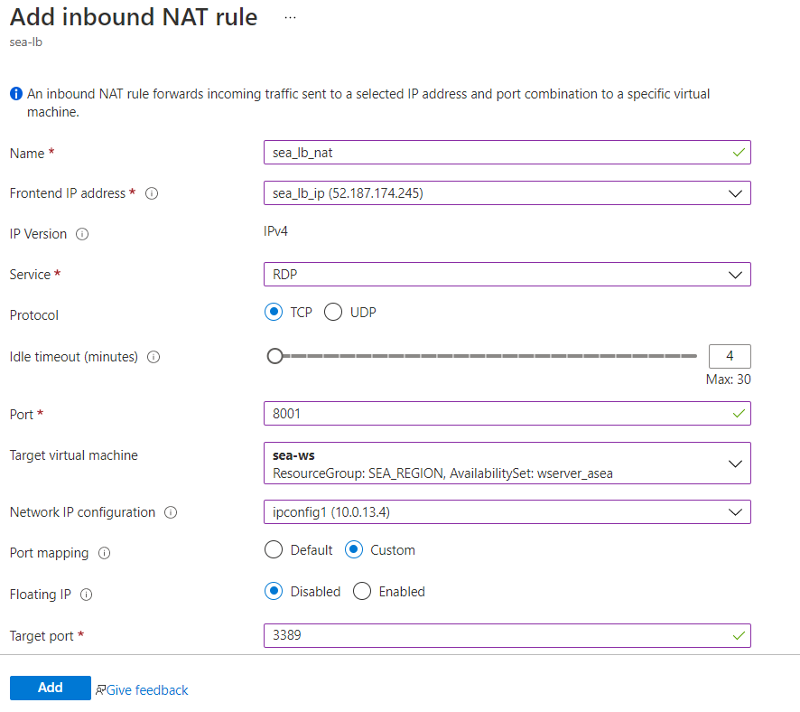

* **Assigned NSG to subnet.**

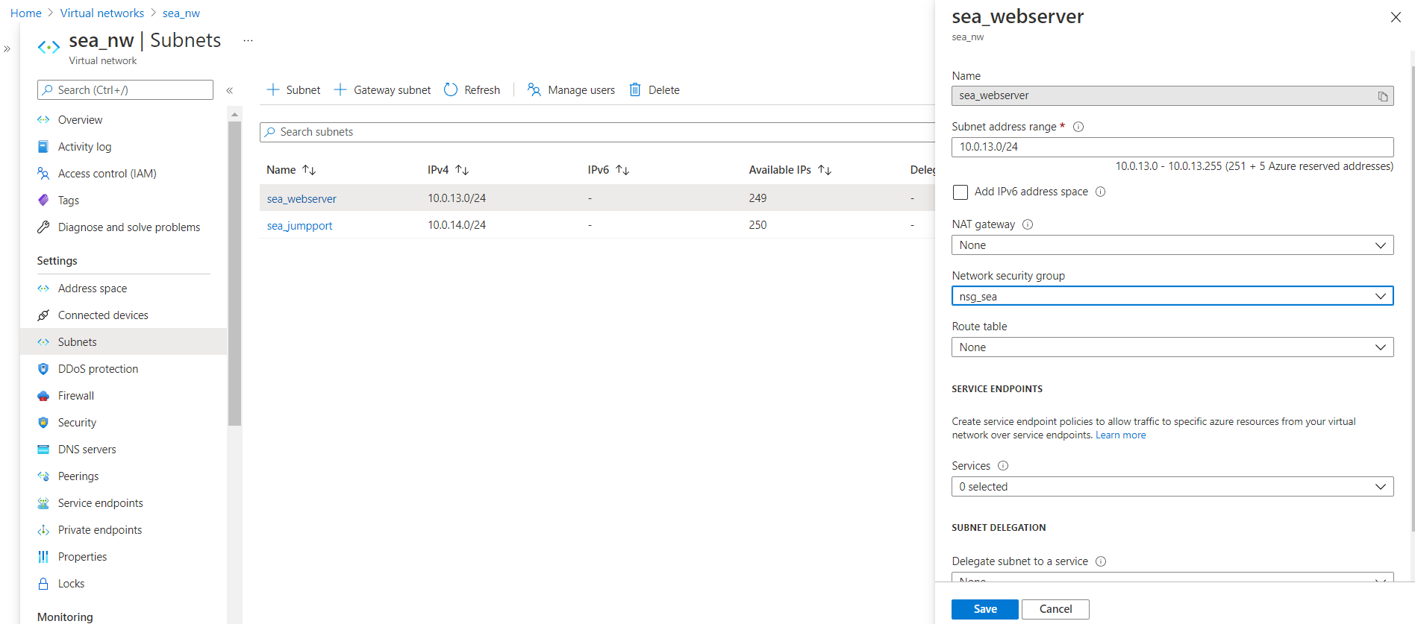

* **Adding Inbound Security Rules.**

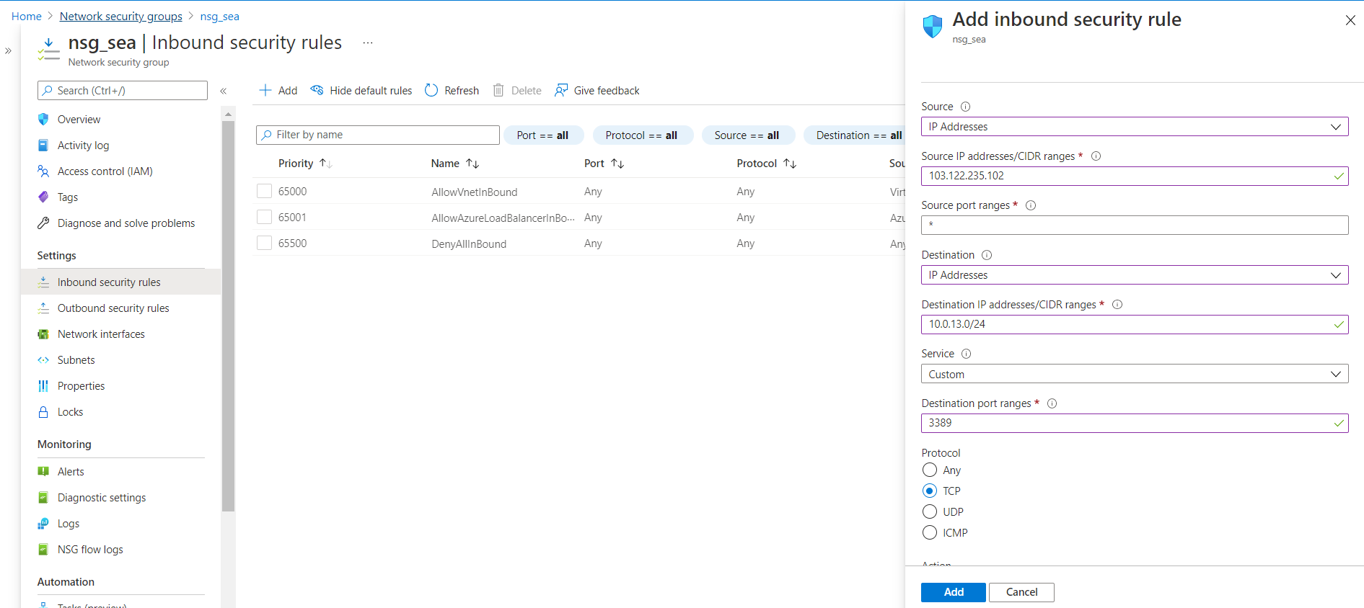

* **Accessing webserver using Inbound NAT rule.**

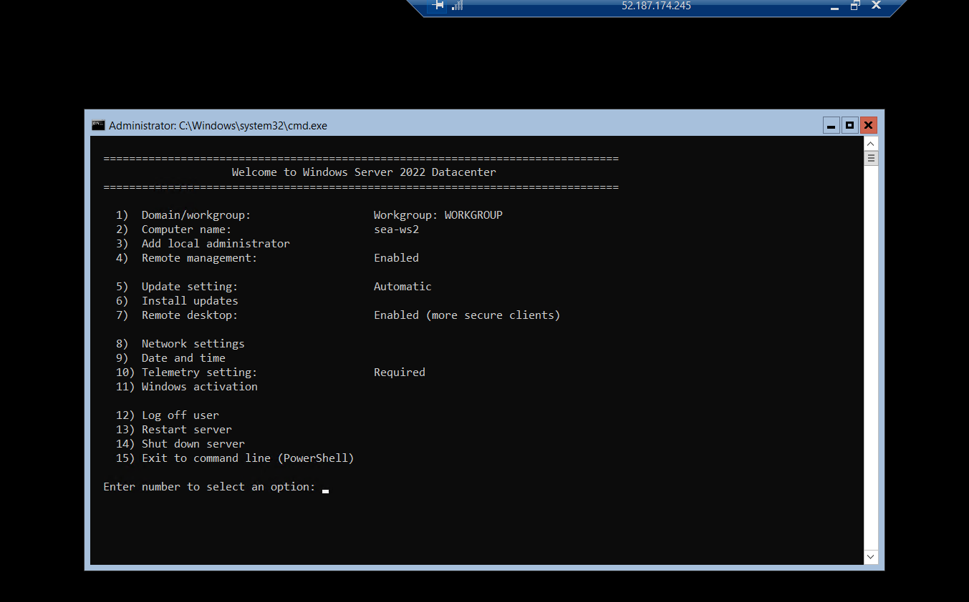

* **Install IIS in VM1 to make it a webserver**

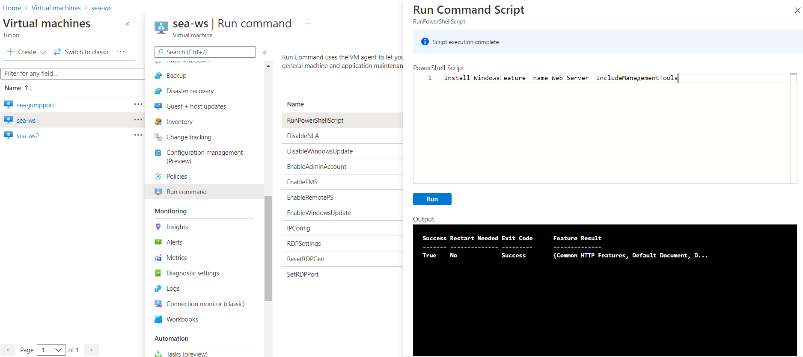

* **Install IIS in VM2 to make it a webserver**

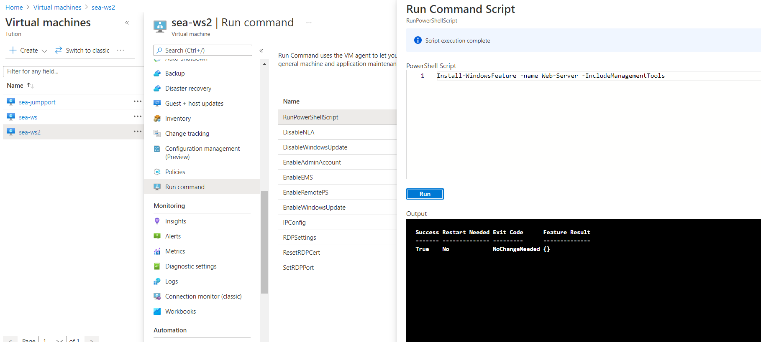

* **Enabling backup**

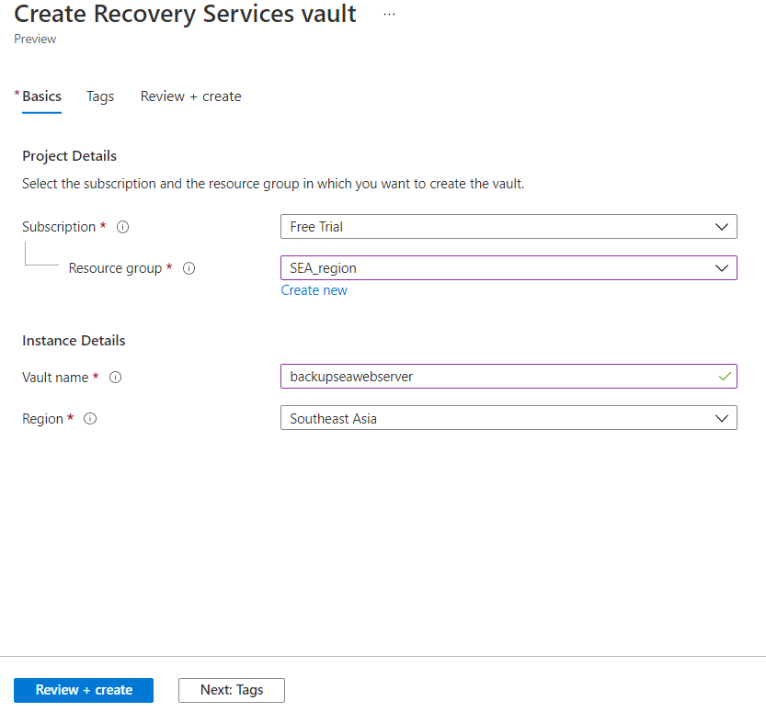

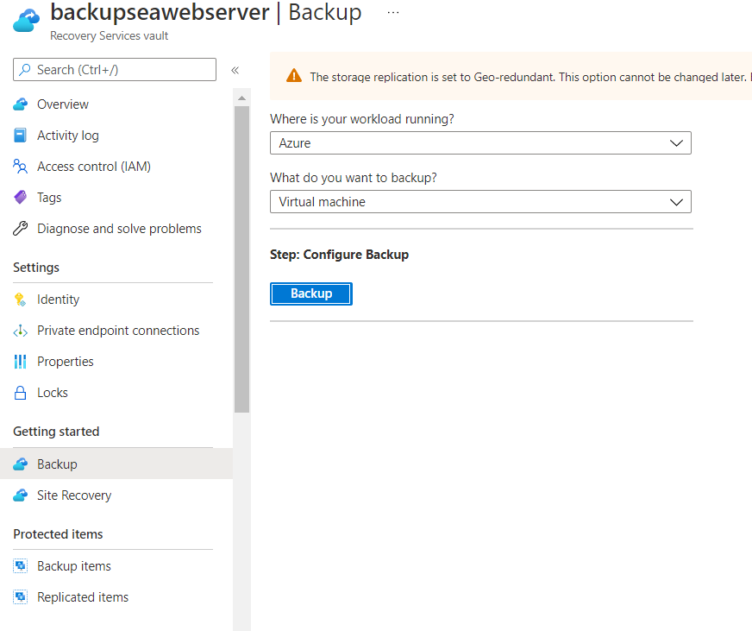

* **Configuring backup**

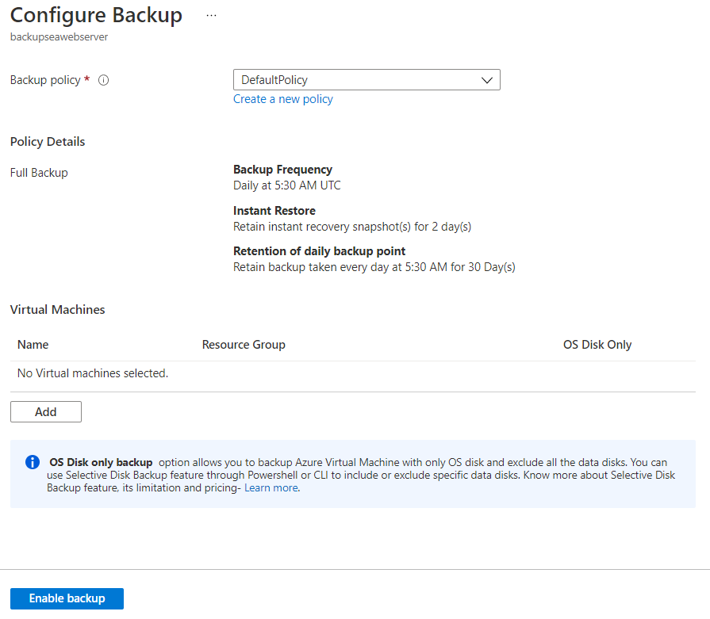

* **Backup enabled for both the webservers in SEA region**

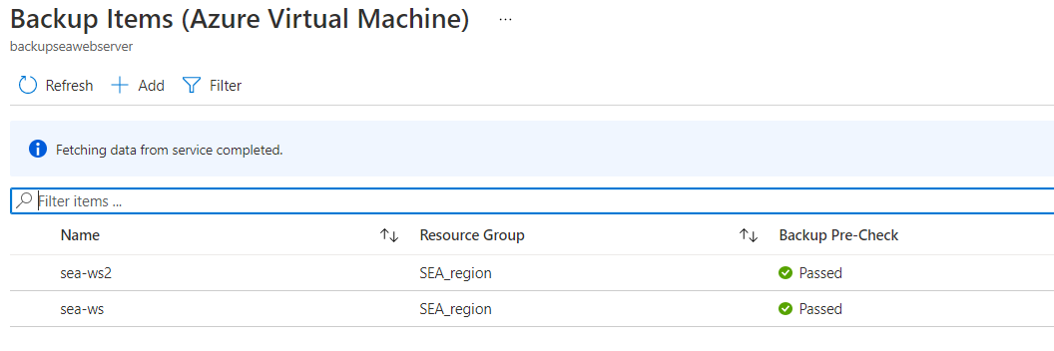

* **Creating alert rule.**

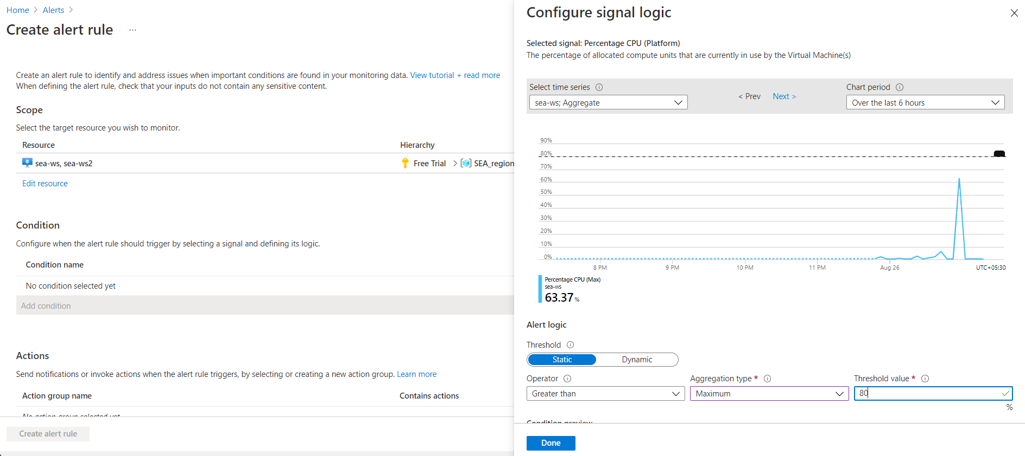

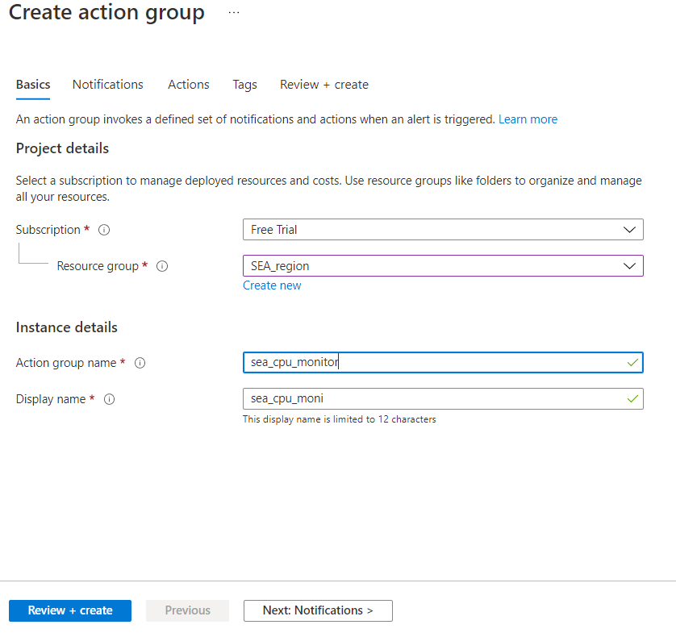

* **Setting up the mode to receive alerts.**

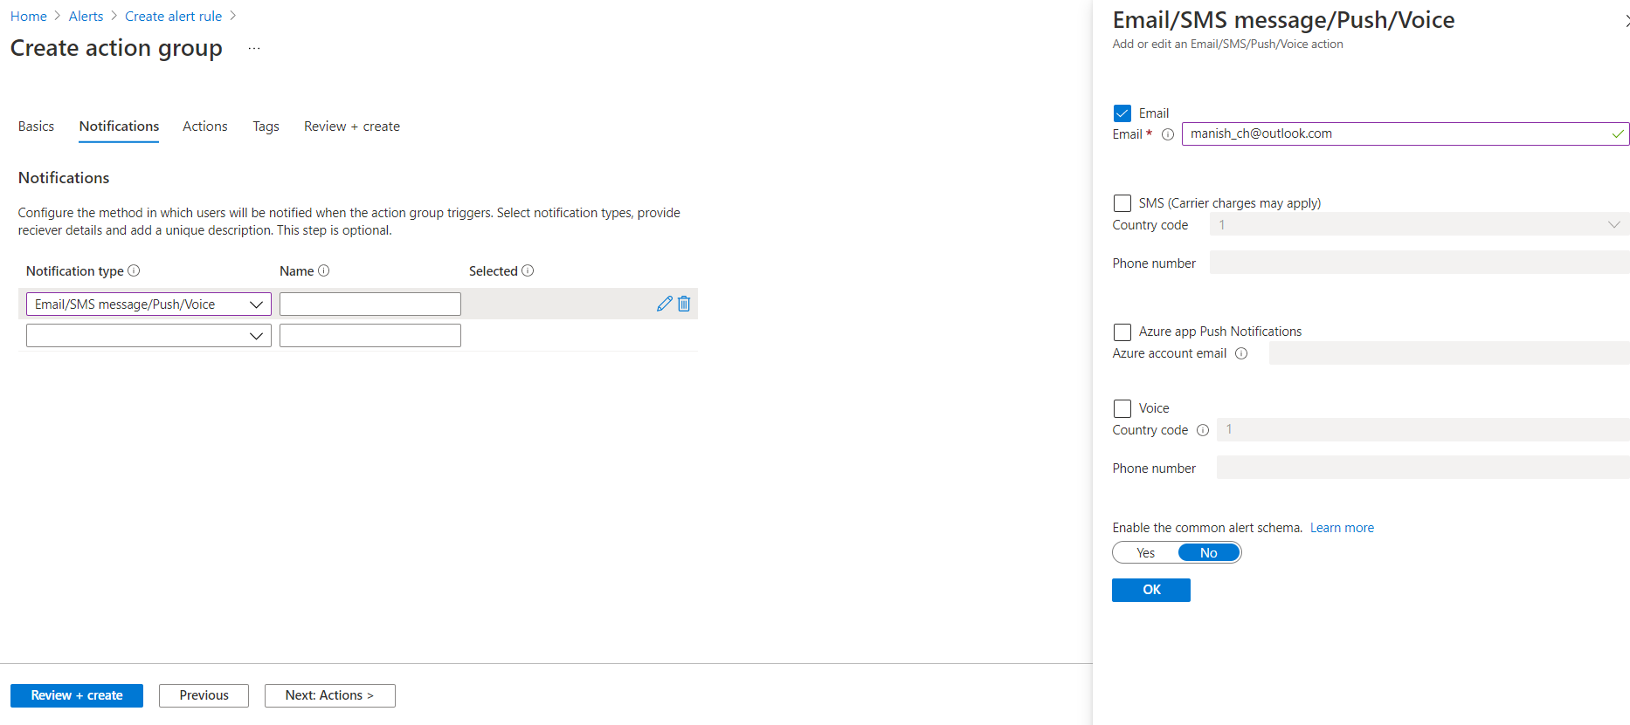

* **Creating alert rule**

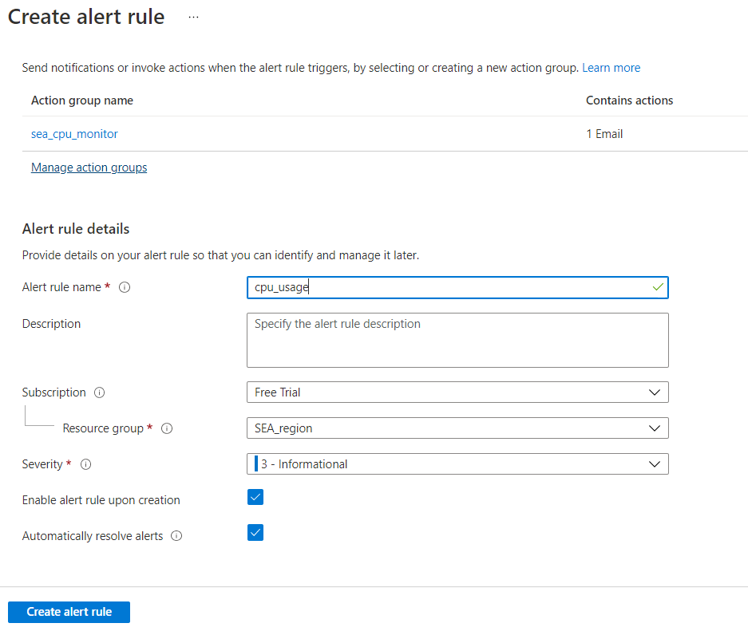

* **Alert rule been created successfully and the email address has been linked to receive notifications.**

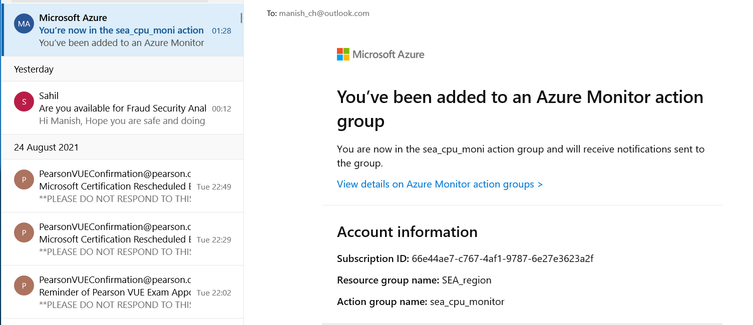

* **Alert Mail received on meeting the conditions created in alert rule.**

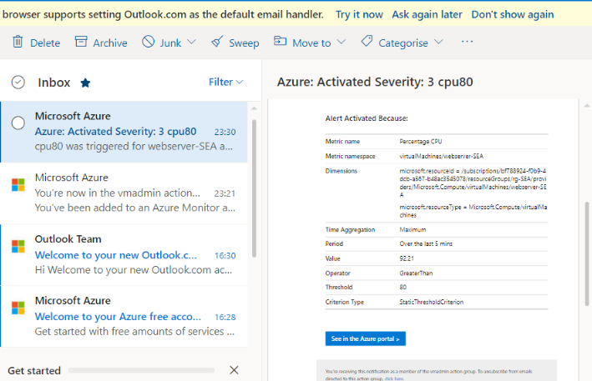

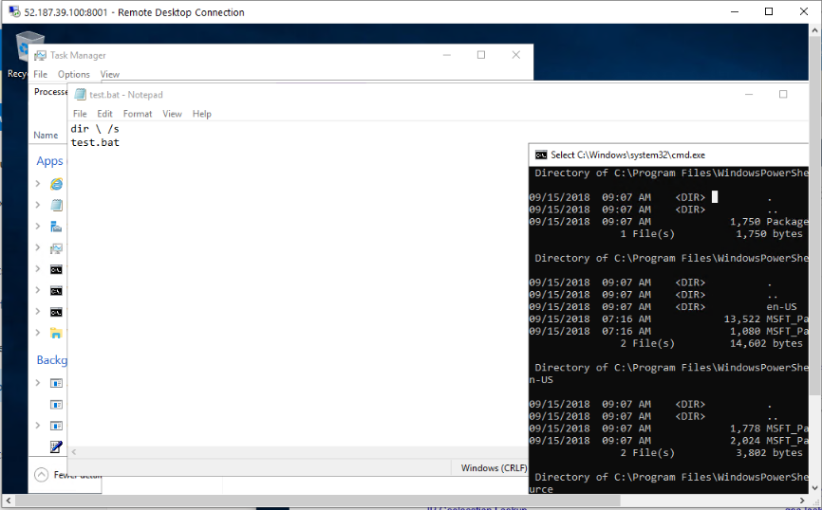

**(Working in East US region EUS)**

* **Creating a Virtual Network in EUS region.**

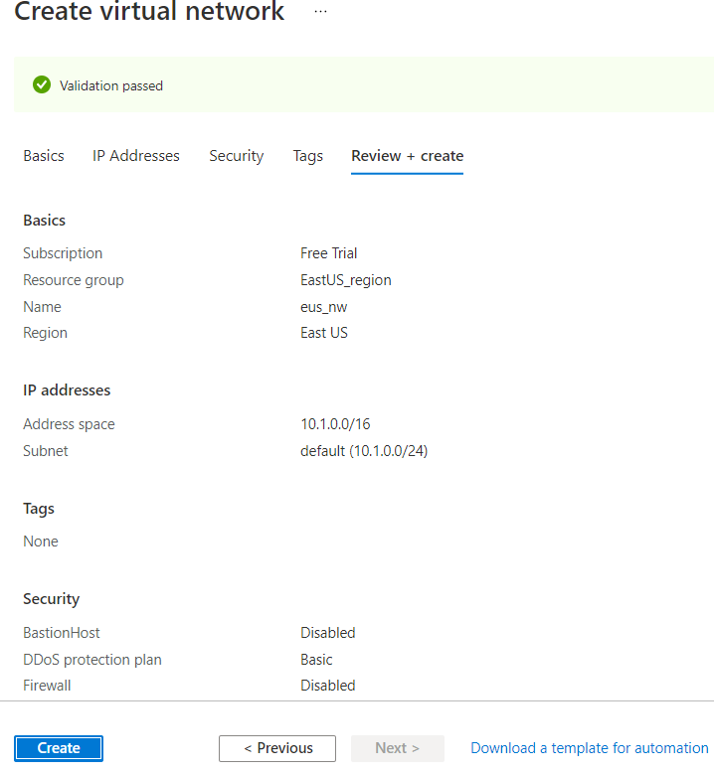

* **Creating a virtual machine in EUS region.**

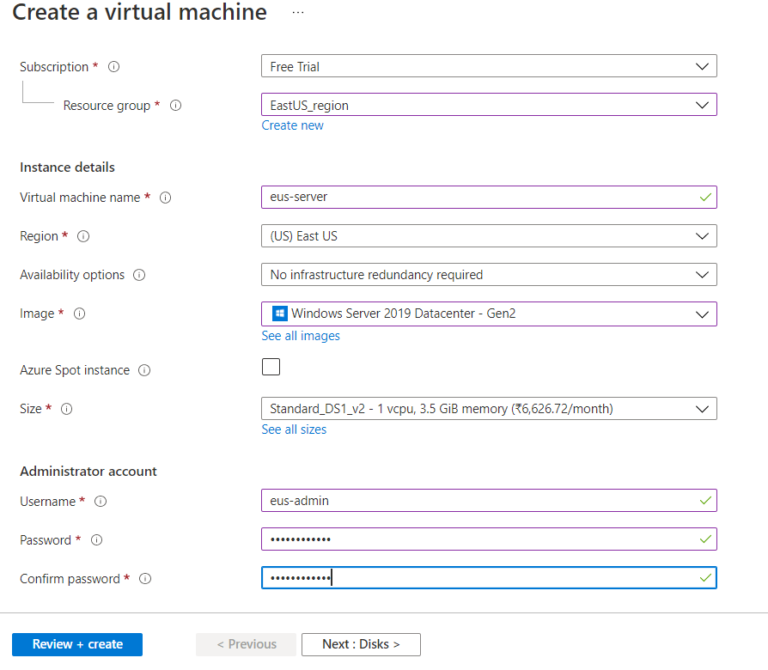

* **Setting up the OS disk size to SSD.**

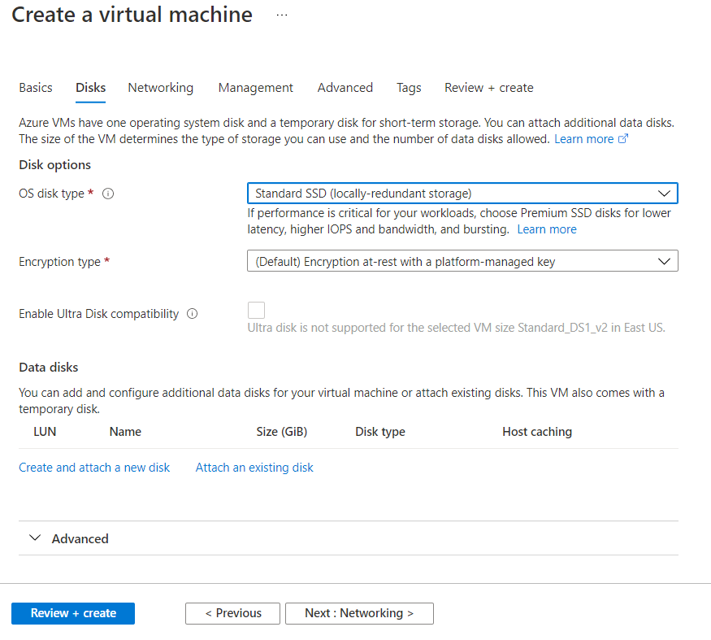

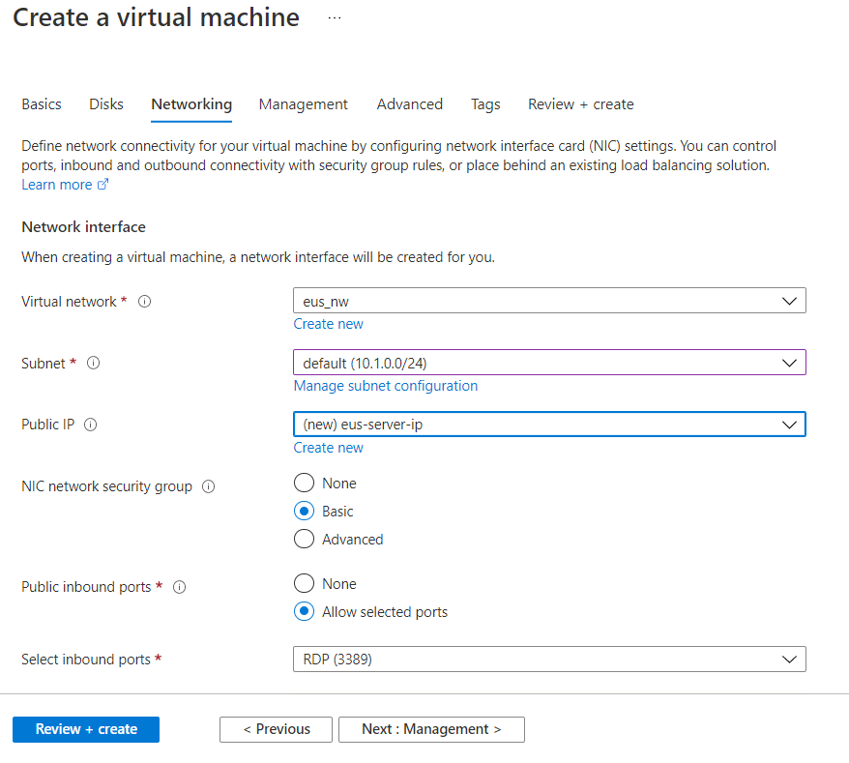

* **Establishing secure Connection to SEA-EUS Azure sites through peering.**

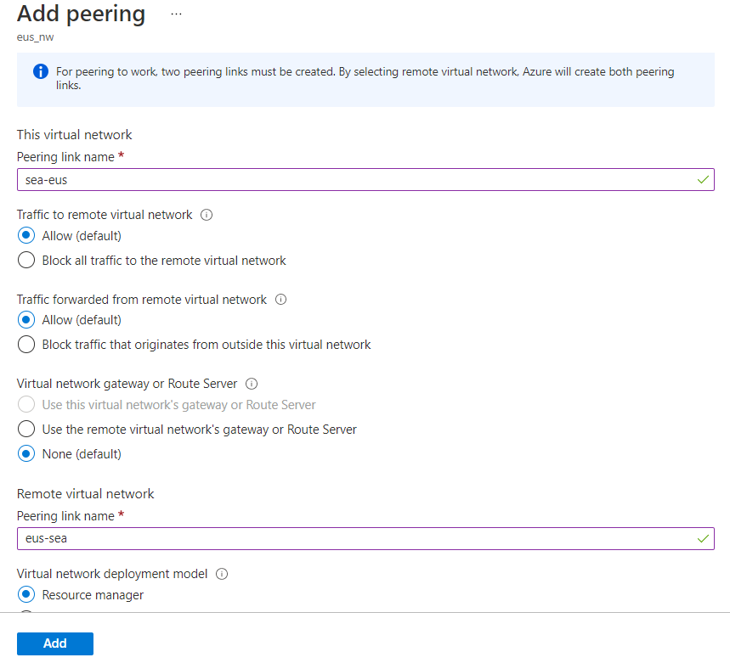

* **Secured connection is established. Peering done successfully.**

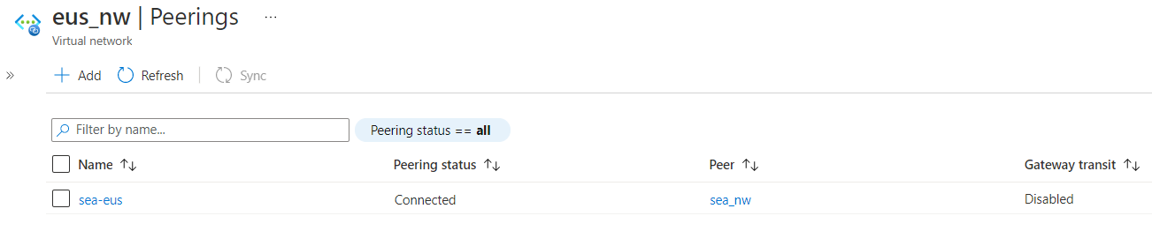

* **servers are reachable with internal ip addresses.**

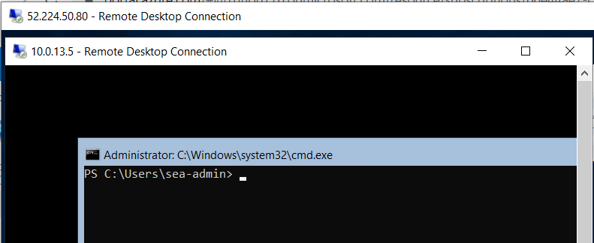

**Storage Requirement:**

* **Creating storage account for EUS region with zone-redundant storage.**

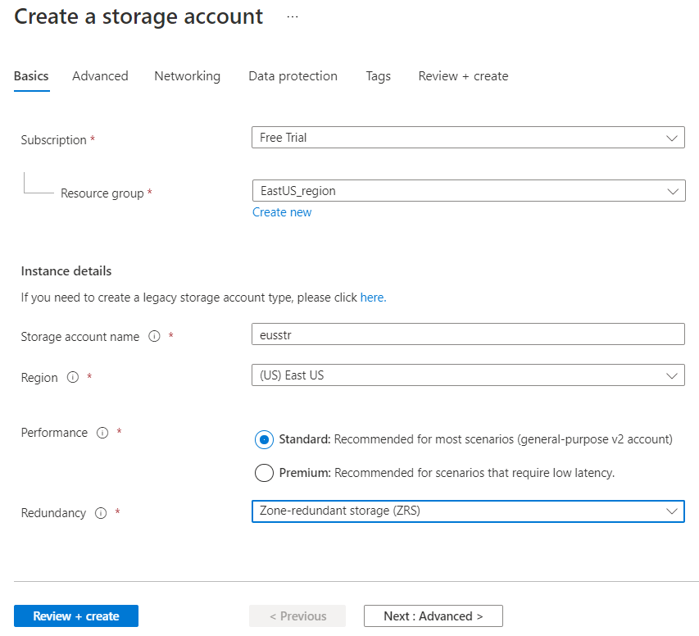

* **Creating secured access for Storage account in EUS region.**

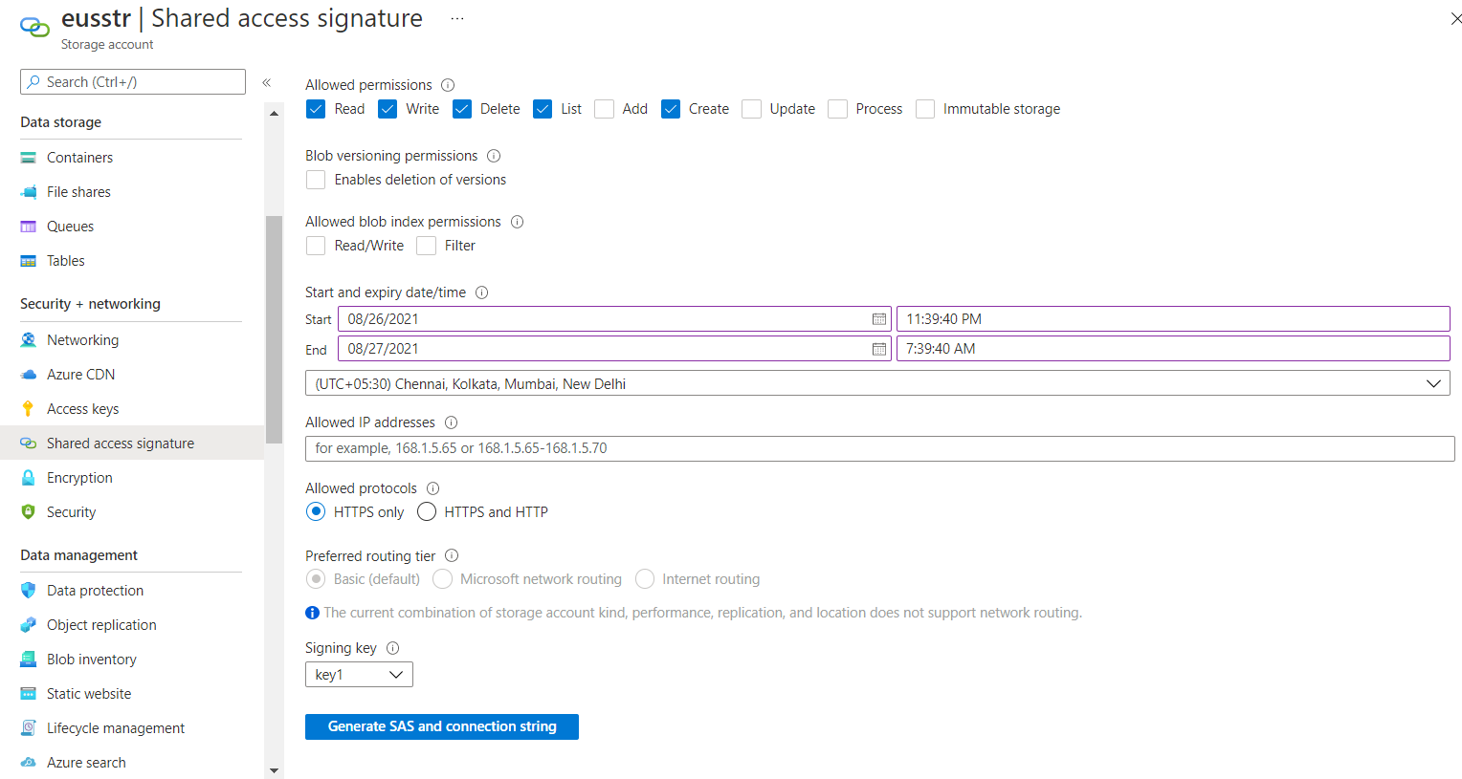

* **Creating Files share.**

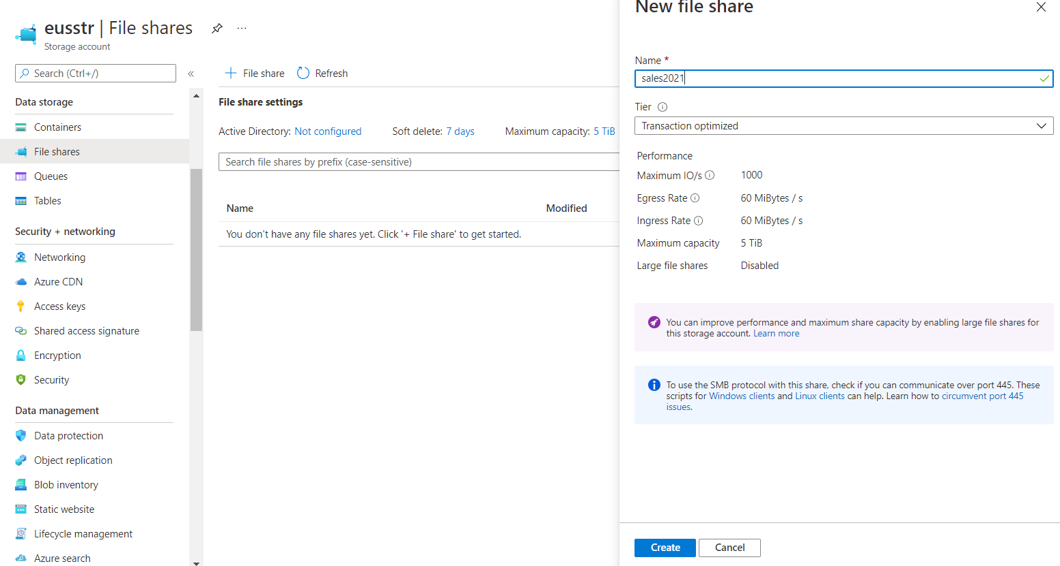

* **Mount the Drive**

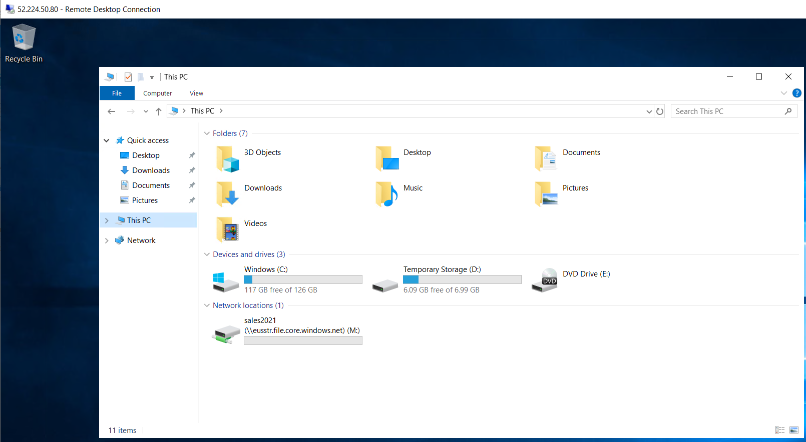

* **Creating storage account in SEA region with Geo-redundant storage to be used in multiple azure data centre failure.**

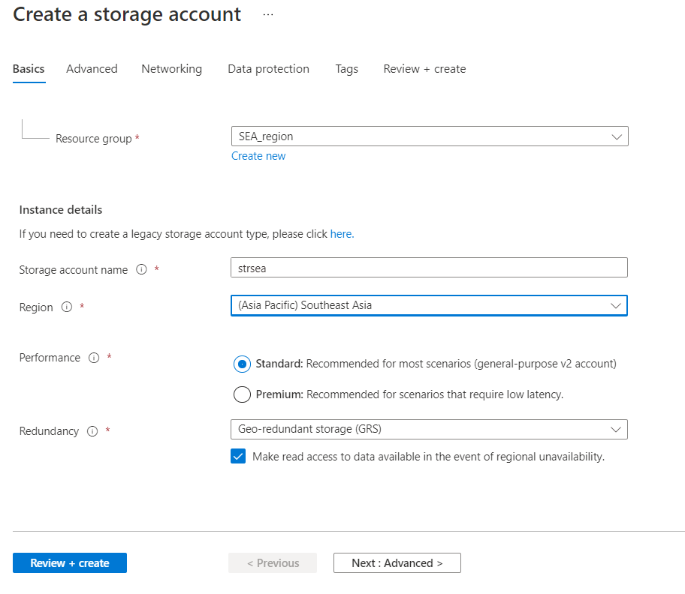

**Azure Resource Management:**

* **Creating server_admin user to monitor all VM in subscription.**

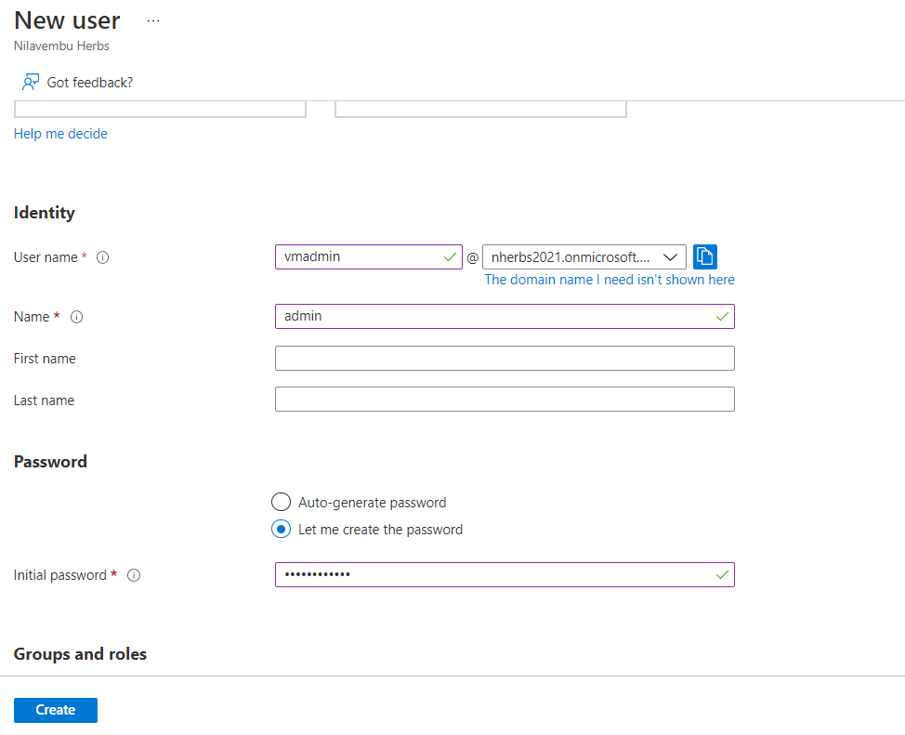

* **Creating Backup admin user, to manage backup only in EUS servers.**

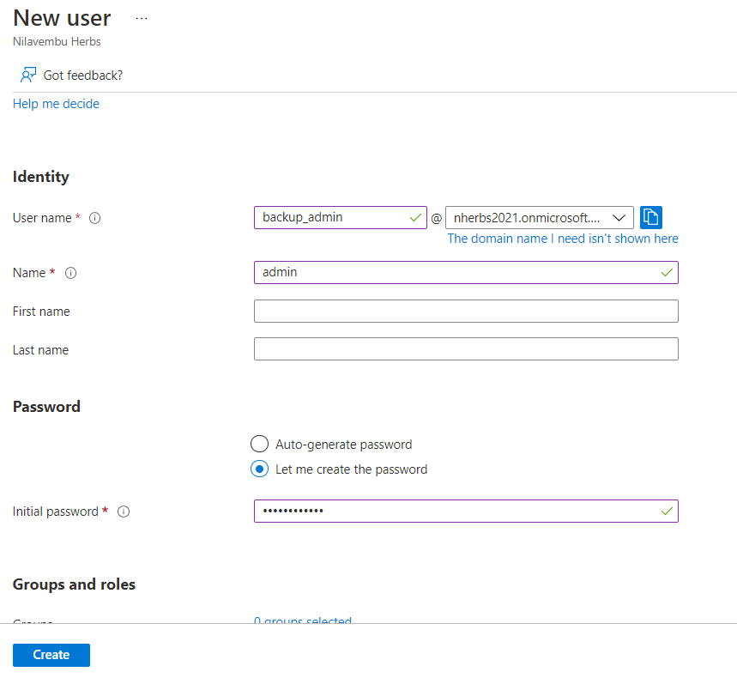

* **Adding roles to the users created.**

